The installation of python and Django is being performed.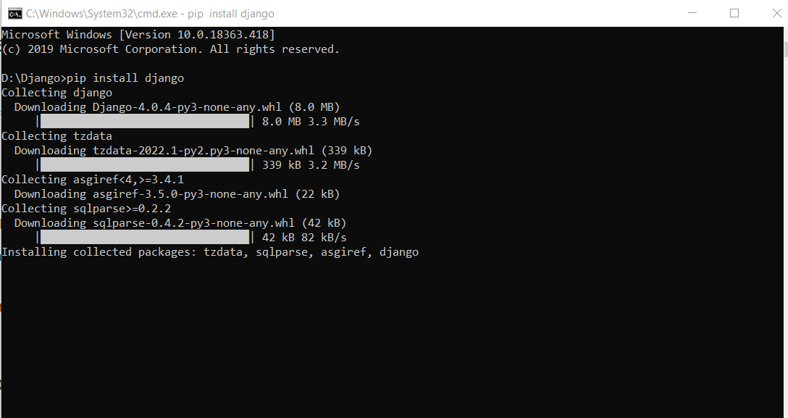

The Django application is installed using the command.

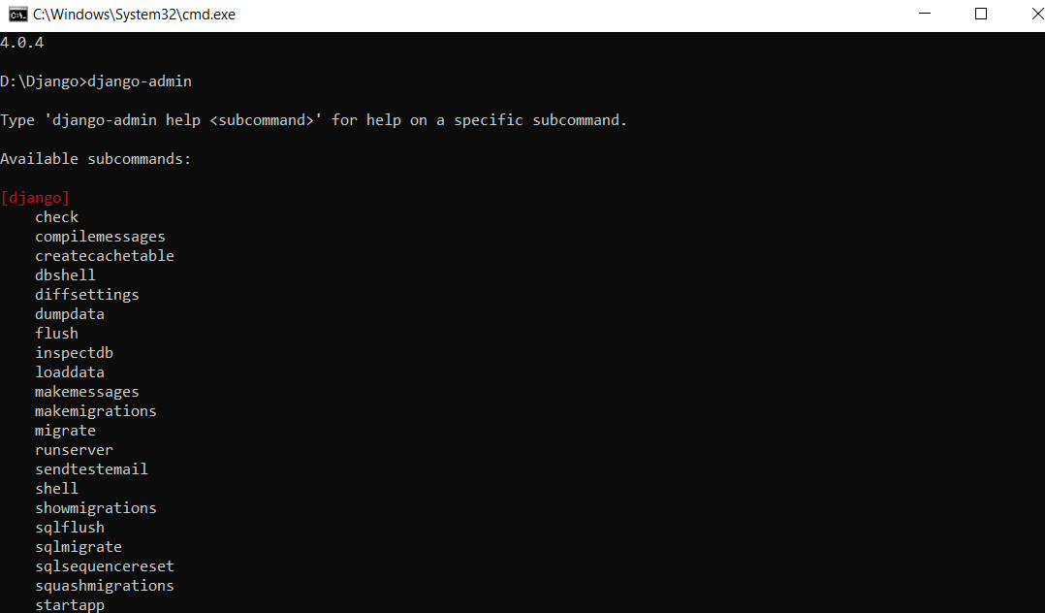

The admin command is being used and the process is performed.

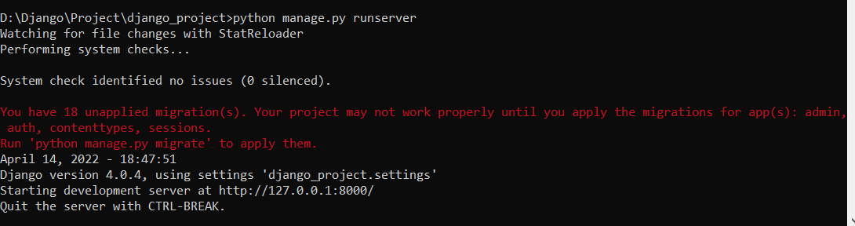

The server is made to run and the address is being displayed.

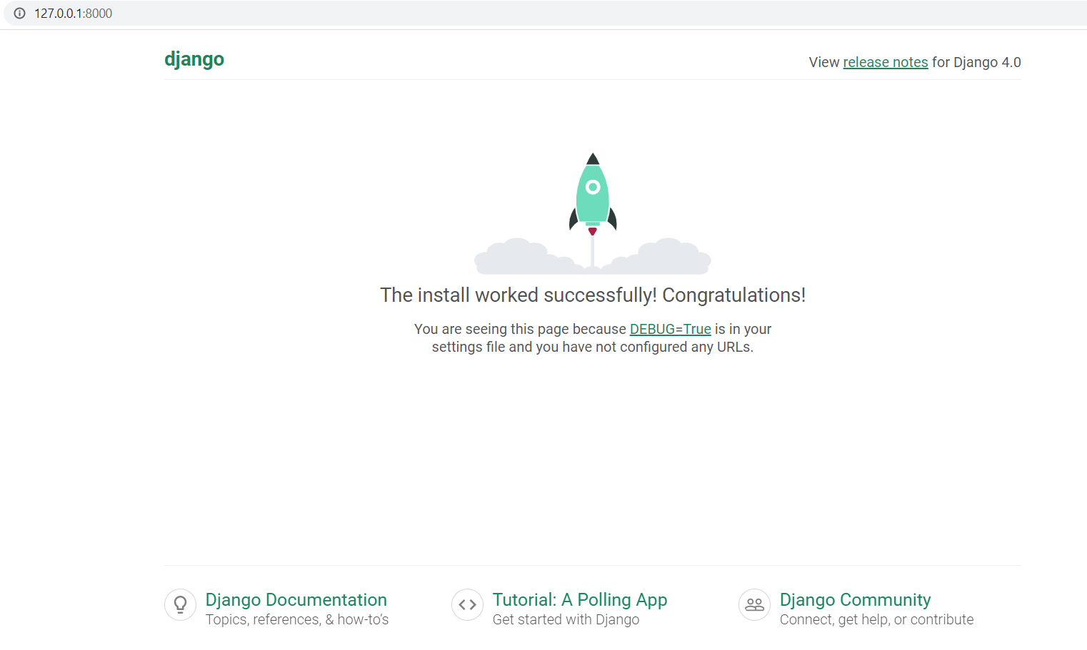

The url is copied to the webpage and the installation of Django is successfully completed and this is displayed in the window.

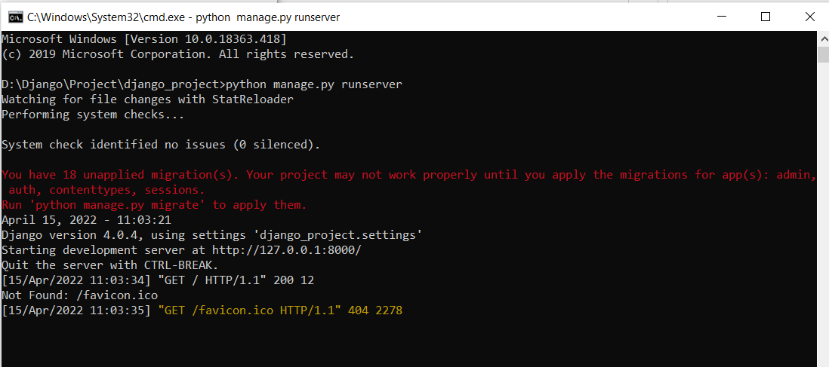

The creation of the pages file and the certain changes in some of the files are made effectively. After completion of changes in the files the server command is used and the url is being displayed.

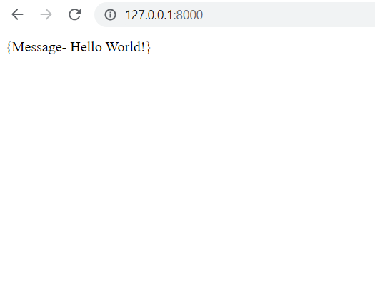

The displayed url is given in the webpage and the Hello world is being displayed in the page.